Final Project Report

Love in Shanghai

(https://oscarzhu8.github.io/COMM5961/FinalProject/homepage.html)

Designed by Zhu Jiajie 1155145692

1. **Introduction**

In order to make college students enjoy dating better, the website called “Love in Shanghai” is designed for the college students who studied in the city to find a suitable and beautiful place for dating. The website will provide recommendations and also demonstrate the details and comparisons between each place, which is also useful to the people from different ages who travels to Shanghai. In this report, the process and development of designing this data-driven website will be illustrated.

1. **Requirement**

**2.1 Why to choose this topic?**

The target users of this website are college students who studied in Shanghai. For me, I was a college student who have studied in Shanghai for 4 years, which means that I am not only familiar with the city, but also know what kinds of problem these students will have. Therefore, the reason of designing a dating place recommendation website for students is motivated by my own experience.

As a college student in Shanghai, I often spent a long time to find out a suitable place for dating, because there are so many places without a clear categorization. What’s more, how long I can play, how far is the place, and whether the place has a high rate are all the factors I will consider, but I usually find difficulties in looking for the aforementioned information. When I asked some of my friends, most of them replied that it is so wasting time to find a favorable place, which are the same with me.

Consequently, I want to solve these difficulties in my data-driven website: how can the college students quickly find out a suitable place for dating, and make them have a thorough understanding and preparation before they date with their partners? My website will mainly contain two objectives: (1) Help college students save time on finding a favorable dating place to date with their partners; (2) Make the couple’s dating life in Shanghai more enjoyable, as well as considering saving money for them.

**2.2 User’s need**

In order to discover the user’s need and their pain points, I made an interview to investigate the relevant problems. The interviewees are college students who lived in Shanghai, as well as those who come to Shanghai for study. The questions are:

(1) How do you find a dating place? What website will you use to search an ideal place?

(2) What kind of functions and information are you looking for when using a website that aims at recommending dating places?

(3) What problems will you have when using the existing platform?

After summarizing the results, there are two main pain points:

(1) On the current platforms, users are aimless in finding a dating place with specific preference.

When we type “dating”(约会) in Dianping, numerous places will come out without a clear focus. In order words, the current platform is not well-structured in categorizing the dating places, whether it is a place with good environment, whether it is place for playing, or whether it is a place for taking photos, etc. As the relaxed time for the college students are limited, they do not have much time to go to all the places, but to go to the most well-known places in Shanghai instead.

(2) The information is not enough to meet the users’ specific needs.

Dianping only provides users with some basic information of the places. As for college students, their expenditures are not the same with adults, so that some of the places are not proper for them, while Dianping does not have a function especially serving for the people from this age cohort. For college students, they should take many things into consideration, such as whether the transportation is convenient, whether it is affordable, whether it is suitable for the young and so on. What’s more, after they finish playing a dating place, they need to find somewhere to eat or rest, while the current platforms do not offer recommendations to this regard.

I also develop a user journey map to see the process of a college student finding suitable dating places, with the aim to examine user needs and explore the opportunities to seize for website development.

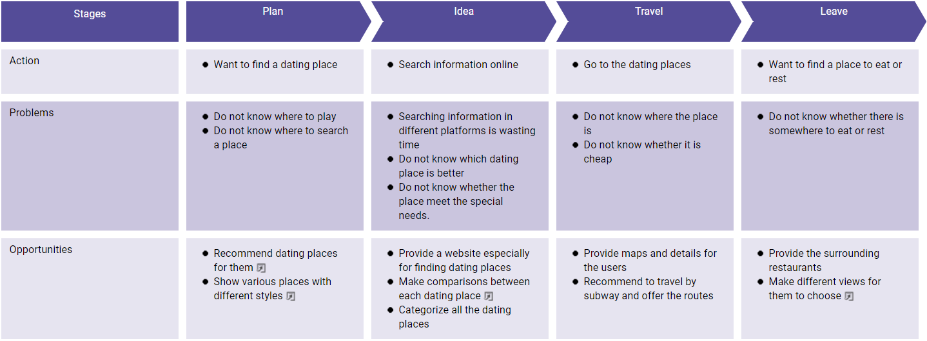

Simultaneously, a data flow diagram and an entity relationship diagram were also created:

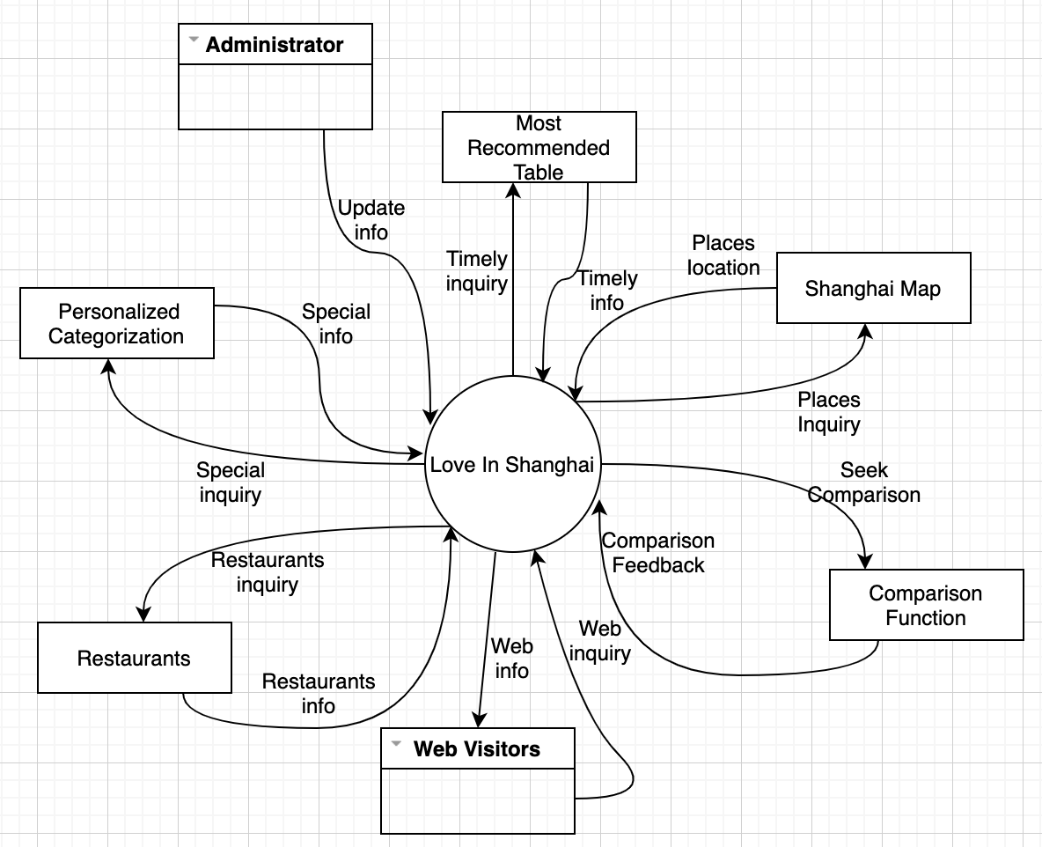

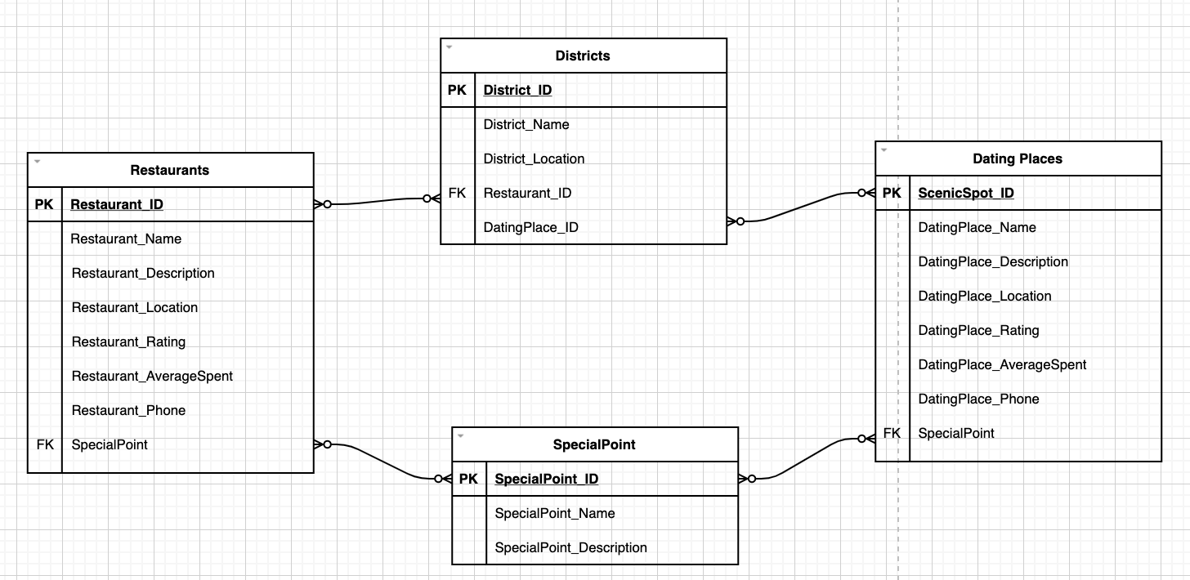

**2.3 Special Points and Functions**

There are mainly three special points of my website comparing with the existing platforms.

(1) My website is especially designed for recommending dating places. The current platforms may help us know the basic information of a place when we have already decided, but if we are thinking of a dating place, the recommendation provided by the current platforms are relatively limited. For example, if we type “约会” in the search box in dianping, the places come out are just some cinemas with the keyword of “约会”, but not offers the recommended dating places to solve the problem. In short, there are no platforms that are specially designed for recommending dating places.

(2) In my website, I offer different functions for users to find a dating place. They can directly choose the most recommended dating places, or select direct views to see the various dating places. I categorize all the dating places into several sections, which will satisfy the different needs of the couples, such as whether it is quiet, whether it is suitable for taking photos, or whether it is a place with privacy. What’s more, users can also see the clear map and the recommended routes, in order to save time and money.

(3) My website not only considers recommending the enjoyable dating places for the college students, but also takes into account their journey after playing. People may get tired and hungry, and my website provides the surrounding restaurants of each place for the users. They can also select different views to see what kinds of restaurants are there near each dating place, while the distance will also be shown. Therefore, users do not need to switch to another platform to find the restaurant, and instead they can continue to stay in my website.

**2.4 Content requirements**

My website includes the following contents:

(1) 30 well-selected dating places in Shanghai recommending for users

(2) 6 websites providing maps to show where are the different dating places

(3) Comparisons and different data views of each dating place

(4) 55 restaurants within 1 km of every dating place collected for the users

1. **Design**

**3.1 Structure**

After thinking about the user needs and requirements, I designed a mind map to show the basic structure of my website, which can be seen from the picture below. Except from the homepage and navigation, the major sections are the most recommended dating places which will be updated monthly, the section for selecting dating places by personal preference, the section for seeing the location and map, and also the section to view the restaurants near to each dating places. Lastly, there is the contact section for receiving advice, and also the footer.

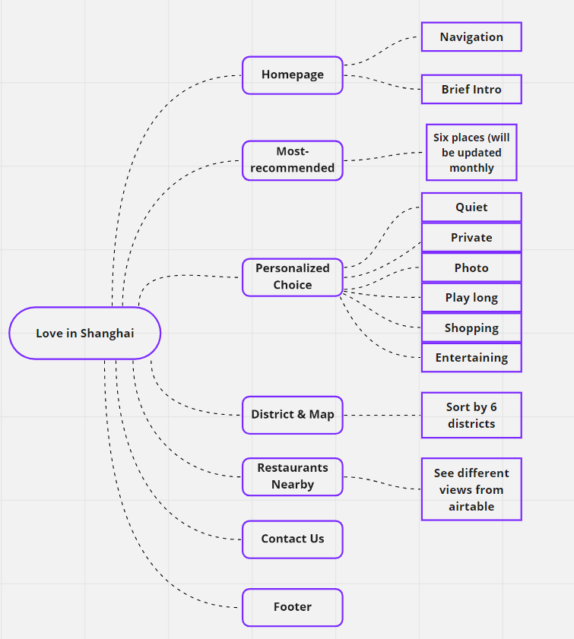

**3.2 Prototype**

According to the structure designed above, I then created a low-fidelity wireframe in Figma to present the ideas more vividly. The pictures below are the demonstration of the prototype.

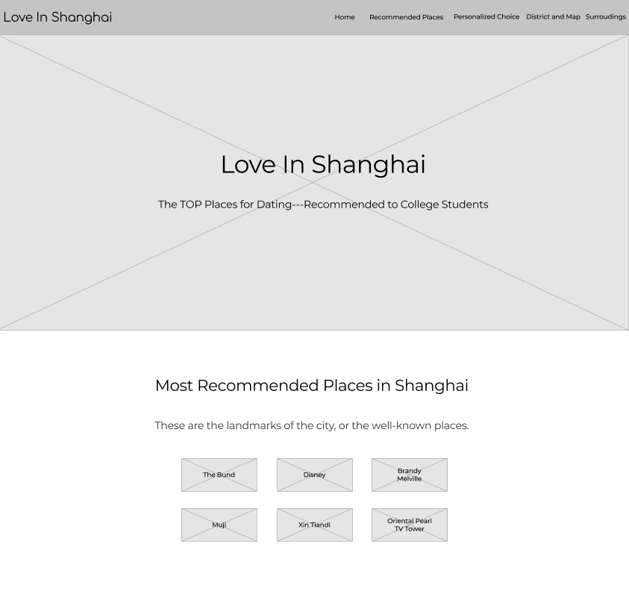

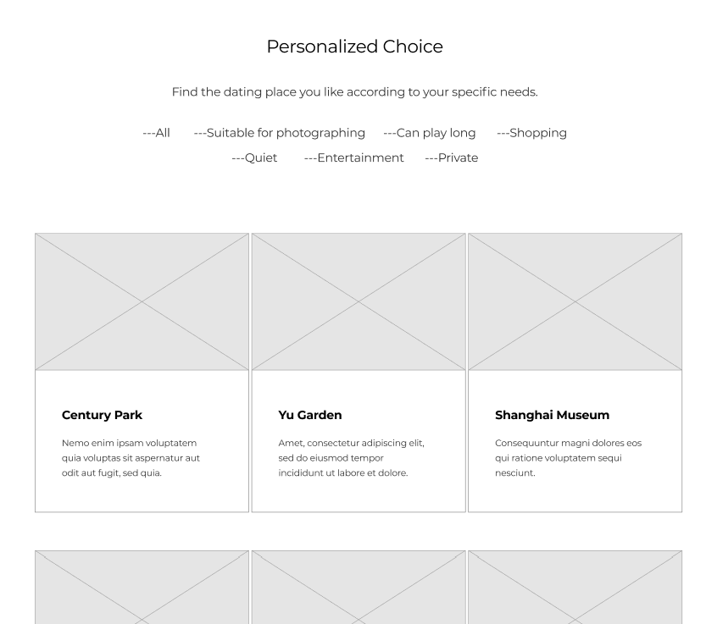

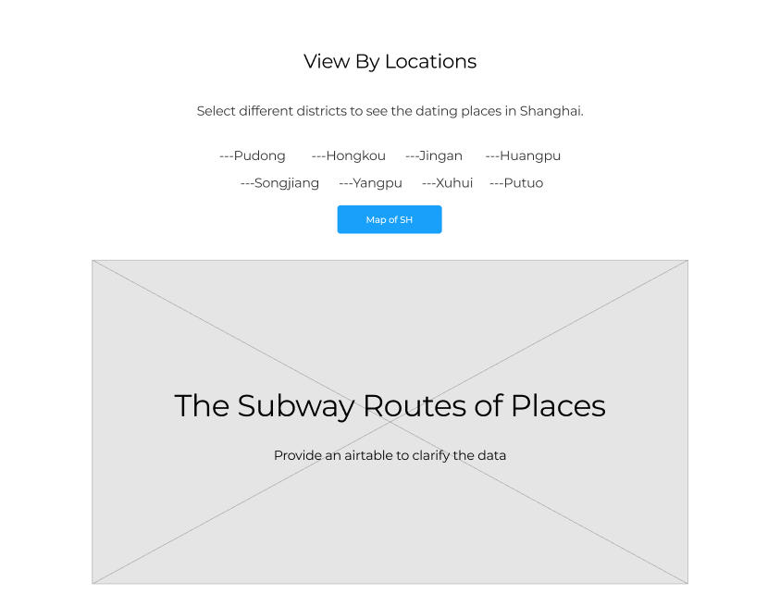

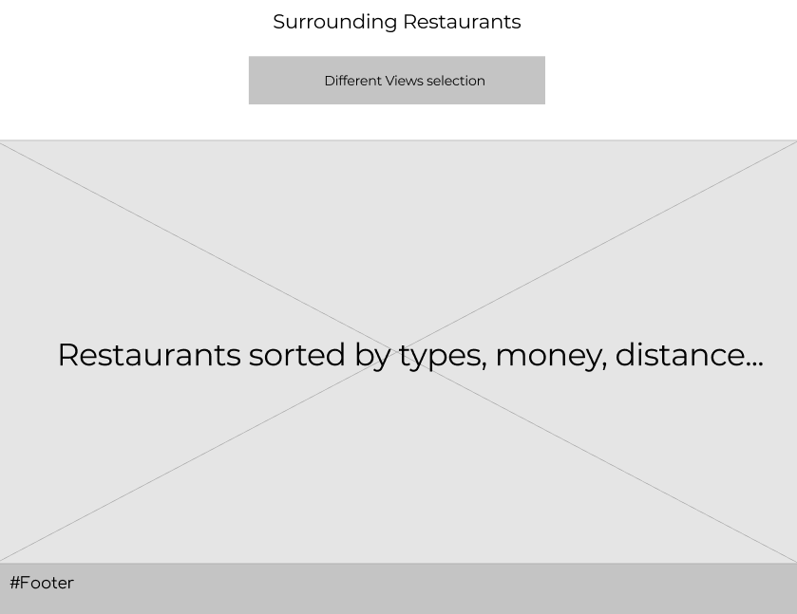

At this stage, in order to seek further improvement when designing the website, I interview 5 college students to get feedback and advice by them. Here are some valuable suggestions from them: 1) Student 1 said that except from the navigation bar, I can add a rolling effect of the homepage, which not only shows the cover, but also the pictures and introductions of the different sections. This will provide more information on the homepage, so that the users will be attracted. 2) Student 3 said that I can add a “Get Started” button on the homepage, which directly leads the users to begin the journey, instead of scrolling the screen. 3) Student 4 said, in the section of personalized recommendation, presenting the sort of “All” to show all the dating places covers too long, and it is better to delete it and only to show the sub-sections such as quiet, private, and etc.

I think that these are all good feedbacks, which I would like to improve in my website design.

* 1. **Website**

After defining the structure, designing a low-fidelity prototype, and gaining feedbacks from the usability test, I finally use html/css/js to develop a responsive website with various sub-pages.

In the front page, there is a navigation bar showing the various sections, and also some automatically rolling pages with some brief introductions of each section. Users can roll down the page, click the navigation bar or click the buttons on the rolling pages to begin the journey. It is worth mentioning that adding the rolling effect is the advice from the previous usability test.

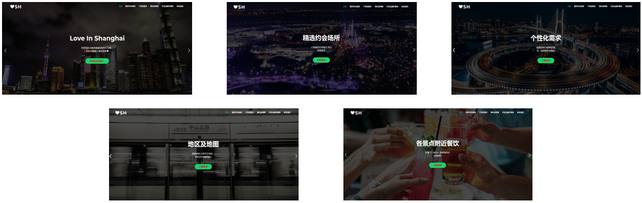In the “精选约会场所” section, users can see the most recommended dating places. They can also click the button to compare the rate between them.

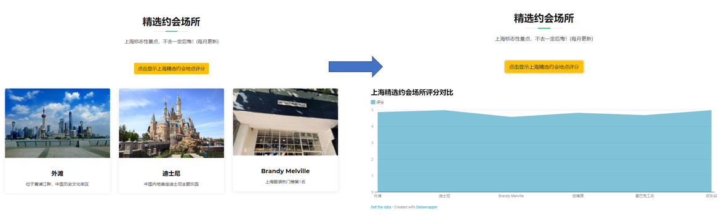

When clicking the picture or title of each dating place, users can go to the subpage to see the detailed information of the site, such as more pictures, more information, addresses, rates, and also comments from others etc.

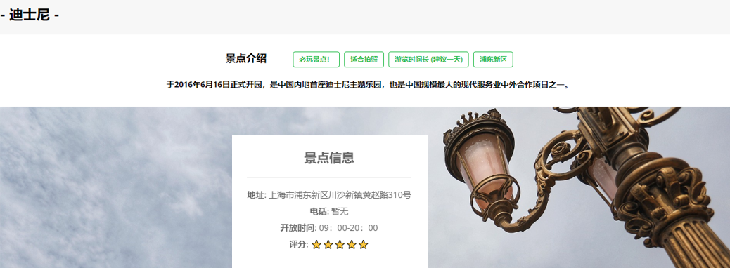

In the “个性化推荐” section, all the 30 places are presented in six categories. Users can filter different places according to their special needs. There is also a function to see the overall rating between each category, and users can click in respective pictures to see the detailed information on the subpage. (30 subpages for each dating place were designed to show more things.)

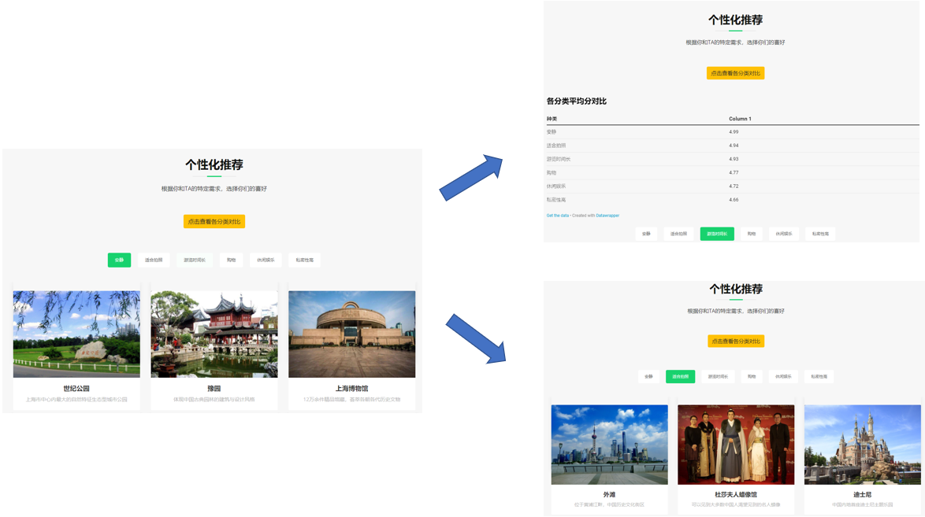In the “地区及地图” section, users can click into different districts to see the map of that area.

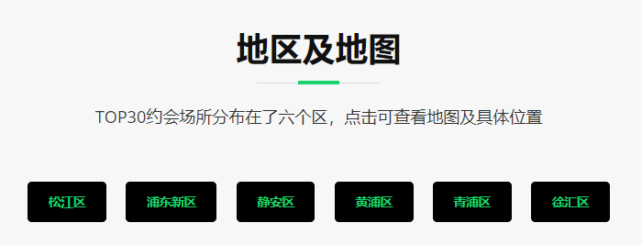

Afterwards, when clicking the special places, an icon will appear to show the exact location of the dating places. If the users click the location icon, a box will appear which guides users to see the detailed information of each place, and the link are the subpages of the 30 dating places mentioned above. These kinds of designs increase the interactivity between my different pages. If the users click out all the locations, they can then click “清除标记” to erase all of them.

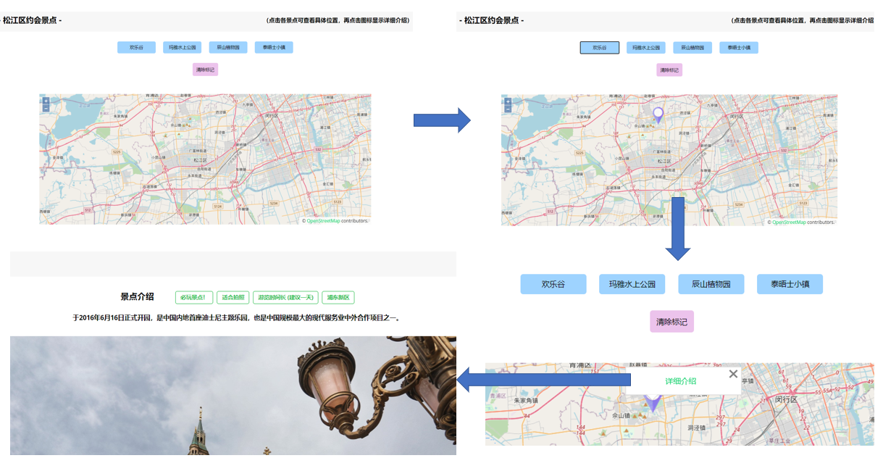

In addition, as the subway is the most convenient and economical way for students to travel, I provide an airtable to show the different lines and stations of each place. Considering some users do not know how to filter in the airtable, I also provided a selection box for the users to see different views, such as by lines and by districts.

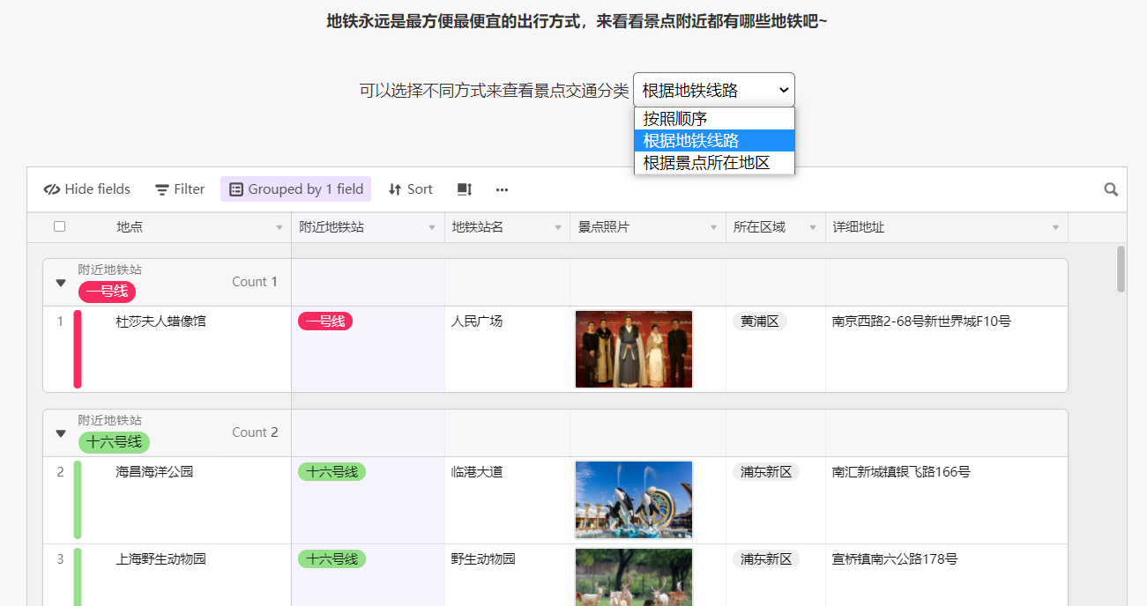In the “各景点附近餐饮” section, I collect the data of the restaurants that are within 1 km of each dating place. Users can also select different views to see the restaurants. It is a useful function when students are hungry after playing a dating place.

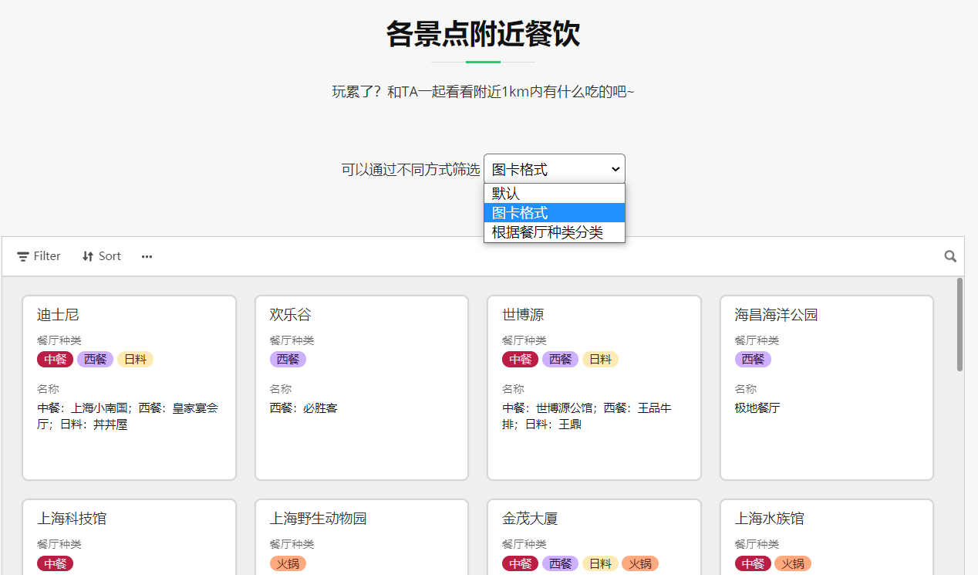

Lastly, there are the contact section and the footer, which sincerely welcomes the users to give their precious comments and suggestions.

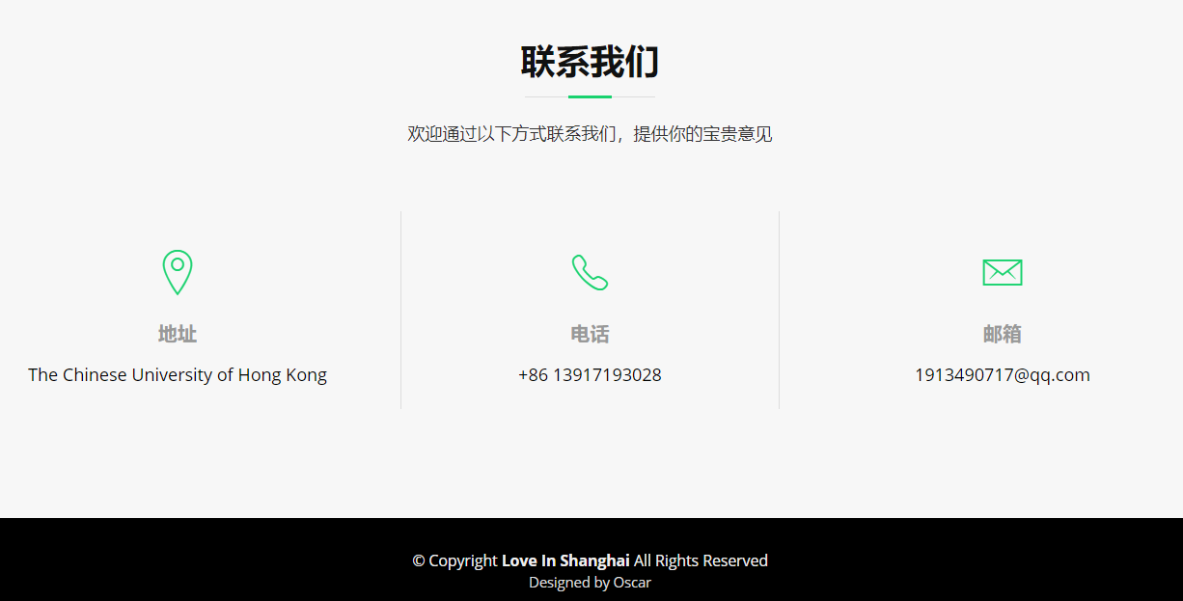

As more and more people use the tablet or phone to view the website, my design is a responsive one that can be applied to different functions. For example, in the “个性化推荐” section, the cards are three in a row from the PC version, and it will automatically change into one in a row from the mobile version.

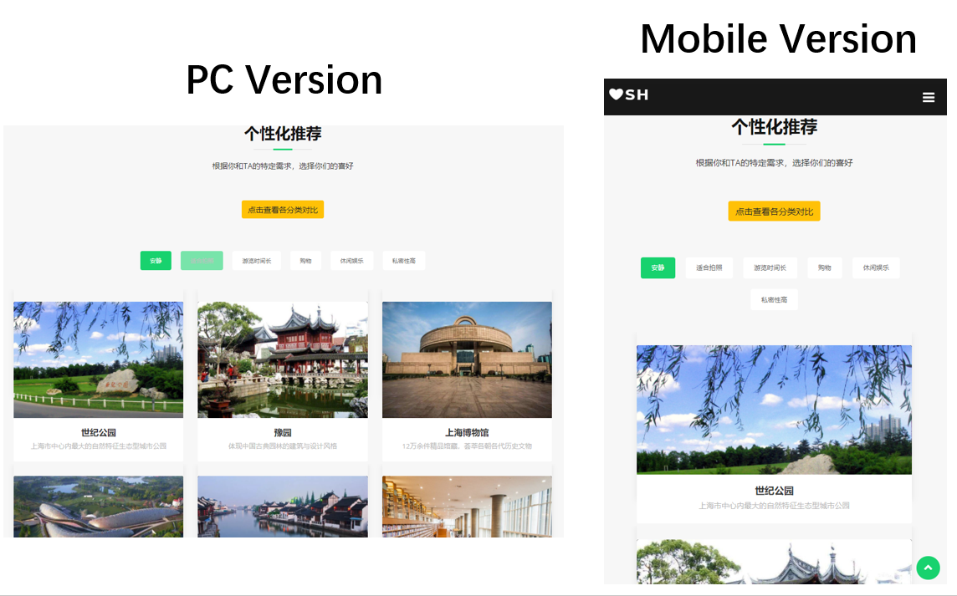

1. **Evaluation**

**4.1 Usability Test**

In order to test whether the users can successfully find what they want in the website, another usability test was carried out for five more college students. They are required to do the relevant tasks and speak aloud when surfing the websites. Therefore, I would observe their behavior as well as see what kinds of problems they meet. Here are the tasks for testing usability of my website “Love in Shanghai”:

(1) View the website and also the subpages for two minutes. Highlight the most valuable information or special function that you notice, and also think about whether there is some problem that confuses you.

(2) Choose a dating place that you like most.

(3) Find out how to get to the place, and think about what can you do after finishing playing that dating place.

In task (1), all of the five users responded that there are a lot of information on the website, which they cannot finish viewing all the things within two minutes. Most of them thought highly of the navigation function. They thought that it is user-friendly and they knew where they are in. In two minutes, they have basically understood the structure of the website, and knew what each section performs. However, there is also a suggestion from student 8: he thinks the photos of each dating place are all very beautiful, but they cover a bit too much of the page, so that he can not see the other information.

In task (2), all of the five users went to the “personalized choice” section to choose the dating place, which shows that the different categorization can meet the various needs from them. In addition, they were attracted by the beautiful pictures of each place, and liked the tags and detailed information and comments in each subpage.

In task (3), three of the new testers directly used the airtable which provides the route of the subway lines to find the efficient ways to get to the dating place, while the other two liked the map very well. They were willing to click into different districts and see where exactly the place is from the map. Furthermore, they all liked the information for providing the surrounding restaurants, as where to eat is also a key factor in every time’s dating. A delicious restaurant, or a restaurant with beautiful atmosphere, will both let the couples enjoy more.

Simultaneously, I also observed the problems that some respondents met. One is that there is no comparison between the most recommended places, which users may hesitate when considering which to go, so that I can add a chart to compare the rate of the places. Another one is that I saw that students are willing to scroll down the page to see the website, but not clicked the “find one” button. Therefore, I think that an A/B test is necessary to find out how can I design the get started button better.

**4.2 A/B Test**

To make the user begin the journey, I designed a “find one” button to let the user get started, and I used the white color, which is the theme color of the homepage, to depict the text on the button. However, the color without highlight may not attract the users to click, which was the observation I got from the previous usability test. Therefore, I want to test whether a button with red text will attract users more. To see which design is better, I carried out an A/B test by Google Optimize for quantitative testing. The test has been lasted for about two weeks, and has gained much data to value the results.

Version A:

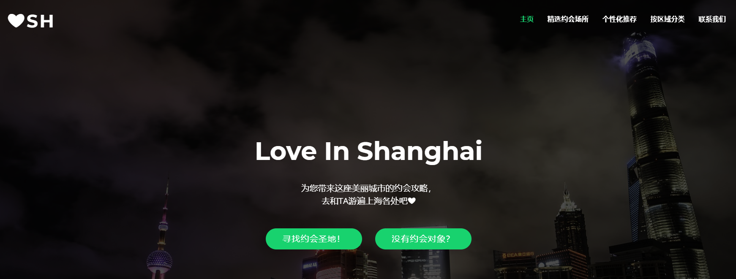

Version B:

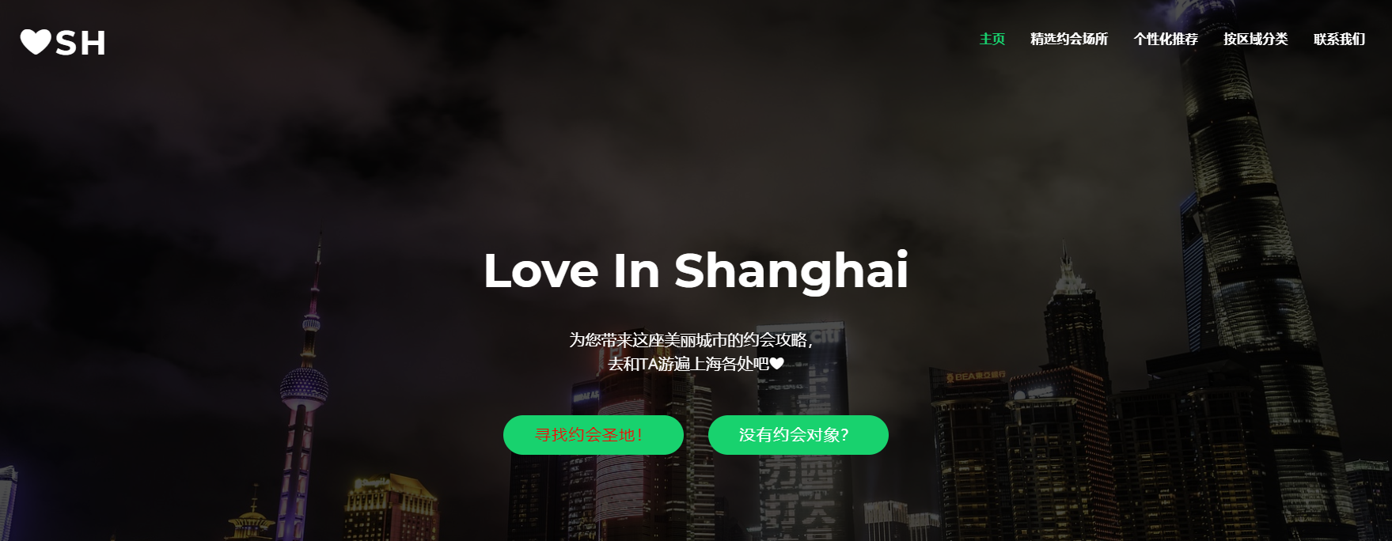

After running the A/B test from November 27th to December 13th, we can see that the performances between the two versions are near, while the version B performed a little better than the version A, which gets more clicks (2.76 to 2.73) and longer page duration (47 seconds to 44 seconds). Therefore, I think the previous hypothesis was being supported, and I would to design a more eye-catching color button to attract users to take action.

The results of A/B test are in the following:

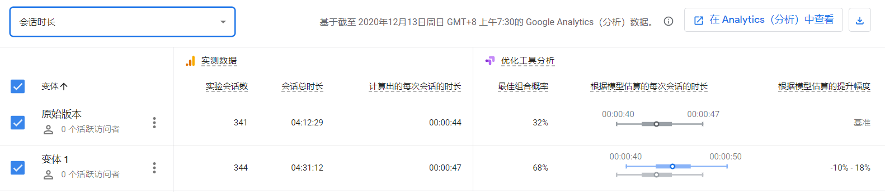

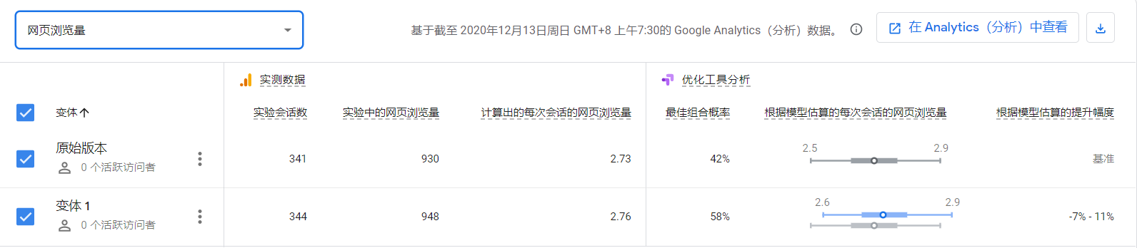

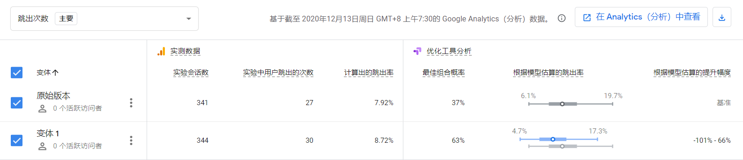

**4.3 Analysis of the Website**

In order to test the performance of my website, I used Google Analytics as well as Google Tag Manager to track the user’s behavior, which will let me have more inspiration for the further developments. The data was calculated from November 27th to December 13th. Here are some of the results:

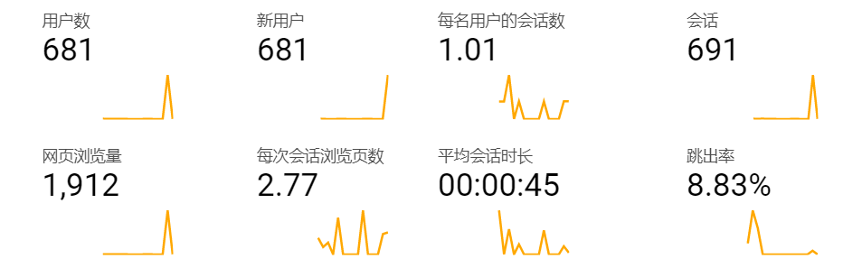

According to the statistics, we can see that every time’s page visits (2.77) and also the average page duration (45s) is positive, as the website for running test is still in the first stage, users will not take too much time to see all the information, and about one minute is really long. However, the bounce rate is a bit high (8.83%). Therefore, in my future design, I would improve my homepage to attract more users to continue viewing, and also add more information on the homepage.

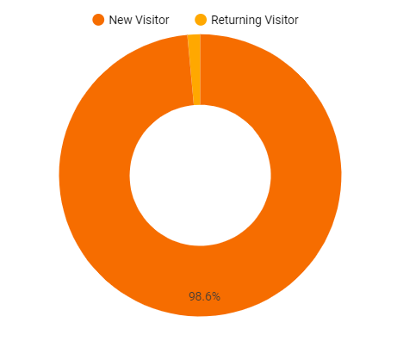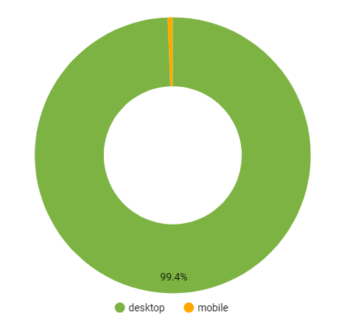

In addition, we can see that the returning visitors of the website is quite low (1.4%), which reminds me that I can add some business case like financial value and benefits for the users, in order to make the users can back for more. What’s more, most of the users are desktop views, so that I can develop more on the mobile views and tell the users they can also use the mobile version to see the website.

**4.4 Recommendation and Future Improvements**

After designing the whole website, there are still some improvements I want to make in the future. Firstly, I would like to monthly update the recommended places, especially the most-recommended dating places. Therefore, after playing all the places, users will still come back frequently to seek new sites. What’s more, I also plan to add some financial benefits in my website. As my website provides the surrounding restaurants near each dating place, I could seek cooperation with the different places and restaurants, such as if you go to a place to date, you can enjoy discount from the nearby restaurants recommended by the website. Therefore, my website can provide some coupons, which can be activated when showing to the respective restaurants.

**4.5 Limitations**

There are still some limitations in my website. Firstly, the dating places may be a little bit less for users who have already been to many places. My initial idea was to select the TOP ones, so that there are only 30, and maybe that is not enough. Therefore, I mentioned above that I will upgrade the new dating places frequently to offer more choices for the couples. Secondly, as the time and the users of the A/B test and web analysis test are limited, some of the points are perhaps not illustrated clearly. Last but not least, because this is my first semester to start coding, the aesthetic and technical level of my website still has many improvement spaces.